Nuclear Engineering PhD Preliminary Exam

Automated Variable Selection of Gamma-Ray Spectra by Utilization of LASSO and Elastic Net Techniques for Use in Nuclear Security Applications

North Carolina State University

Raleigh, North Carolina

February 21, 2019

Vincent A. DiNova

Presented to the Committee:

|  |  |  |  |  |  |
| --- | --- | --- | --- | --- | --- |
| |  | | --- | |  | | |  | | --- | |  | | |  | | --- | |  | |
| Dr. Dimitry Anistrotov | Dr. Ge Yang | Dr. Steven Shannon |

|  |  |  |  |
| --- | --- | --- | --- |
|  | |  | | --- | |  | |  |

Dr. Ralph Smith

With Committee chair:

|  |  |  |  |
| --- | --- | --- | --- |
|  | |  | | --- | |  | |  |

Dr. Robin P. Gardner

**CHAPTER 1**

**Introduction**

1.1 Background

Shortly after the tragedies of 9/11/2001, the National Academies of Science commissioned a study on the dangers of long-lived radioisotope sources.  The study concluded that there exist several commonly used sources that could potentially be used as a dirty bomb or terror weapon (Table 1-1).  The Consortium for Nonproliferation Enabling Capabilities (CNEC) was funded in 2014 to research innovative ways to address nuclear security problems including finding suitable replacements for dangerous radiological sources.

Table 1-1: NAS findings

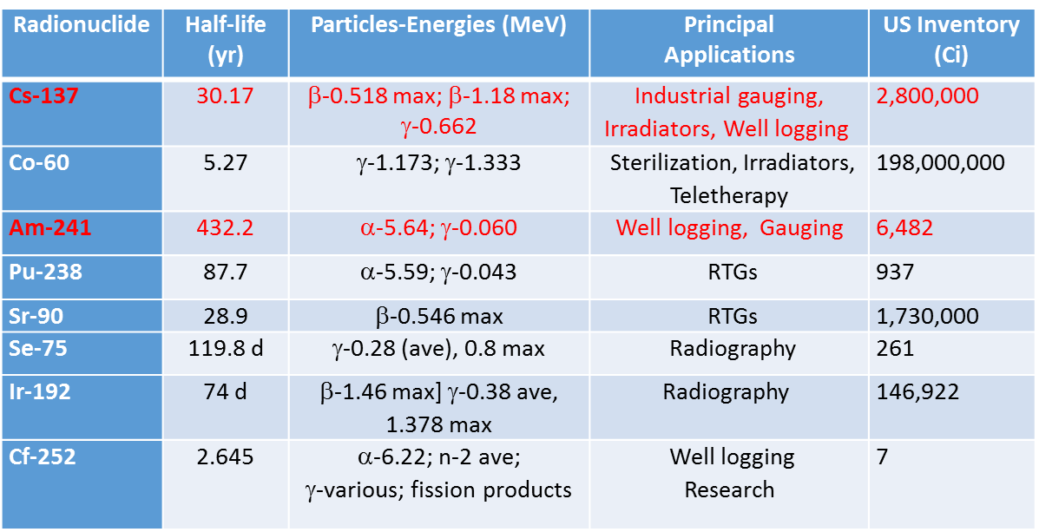

Devices used in the oil well logging industry were identified as a major point of interest as they utilize high activity Cs-137 and AmBe sources for density, porosity, and elemental composition measurements.  A testing facility and benchmarking tool were designed and built at Kansas State University to test the viability of replacing traditional active sources with a D-T Pulsed Neutron Generator (PNG).  A PNG operates by receiving a signal to initialize a pulse firing sequence that propels Deuterons and Tritons on a collision releasing 14.1 MeV neutrons. These high-energy neutrons are used as an alternative to AmBe neutrons in a traditional prompt gamma neutron activation analysis (PGNAA) application. PGNAA is a nondestructive method that relies on (n, γ) neutron capture, and (n, n’γ) neutron inelastic scattering reactions to produce gamma photons, each having distinct characteristics of the target nuclei. Using a near and far NaI scintillator detector, each spectra can be analyzed for elemental composition.

PGNAA suffers from a low signal to noise ratio caused by the delayed activation of nuclei or neutron activation analysis (NAA). Neutron activation analysis utilizes the delayed gamma rays from radioactive daughters, while PGNAA exploits the prompt gamma rays (Fig. 1-1). The neutron cross sections for both prompt and delayed reactions compete and create a mixed signal that is often difficult to process. Additional sources of interference include:

1. γ rays produced by the PNG
2. γ rays from activation inside the detector medium (Gardner 2000)
3. γ rays from background sources
4. γ rays produced by the activation of construction materials in the benchmarking tool.

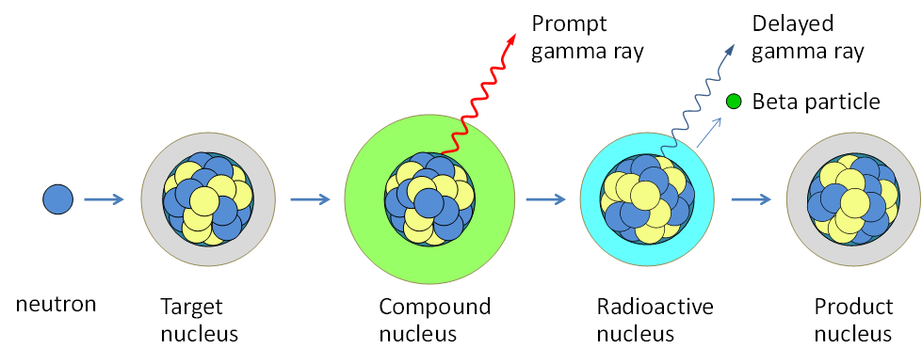

Figure 1-1 Prompt and delayed gamma ray emission process

The PNG offers a unique solution to this problem by exploiting the pulsing time responses with a digitizer, the prompt and delayed responses can be extracted and separated. This critical step allows for supervised machine learning variable selection techniques such as LASSO and Elastic Net to be applied to the prompt and delayed responses, offering on line analysis in a changing environment with improved capabilities over traditional linear least squares methods.

1.2 Benchmarking tool and facility

The benchmarking tool and design facility were designed and constructed at Kansas State University. The tool consists of near and far gamma and neutron detectors separated from a D-T PNG source by a 2” lead divider (Fig. 1-2). A CAEN 5730 digitizer acts to both send the pulse firing sequence to the PNG and to collect the responses from the gamma and neutron detectors (Fig. 1-3).

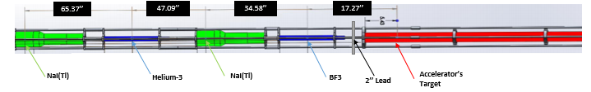

Figure 1-2: KSU benchmarking tool

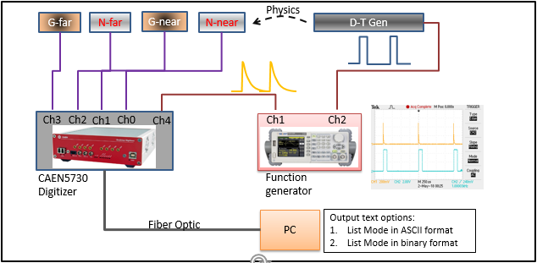

Figure 1-3: Data acquisition scheme

The design facility (Fig. 1-4) is located at King Hall Annex at Kansas State University. Special accelerator enabling systems were required to gain approval from the Kansas Safety Board to prevent inadvertent neutron production and entries into the facility. These safeguards include audio and video surveillance, controlled access points, intercommunication systems, warning lights, and detailed operating procedures to minimize unnecessary dosage to bystanders.

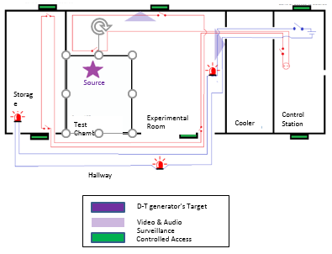

Figure 1-4: KSU design facility

The test chamber (Figs. 1-5, 1-6) is 6’8” high by 6’6” wide and 8’ deep with a total volume of roughly 2,500 gallons. These dimensions ensure that when fully filled with water, the test chamber presents an effectively infinite medium to the 14.1 MeV neutrons. During the data collection process, the benchmarking tool is loaded into the borehole tube and enclosed by a cap. Borated polyethylene (green material) has been fitted both inside and outside the test chamber to reduce neutron escape and dosage.

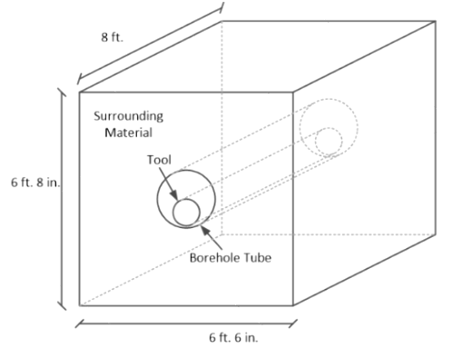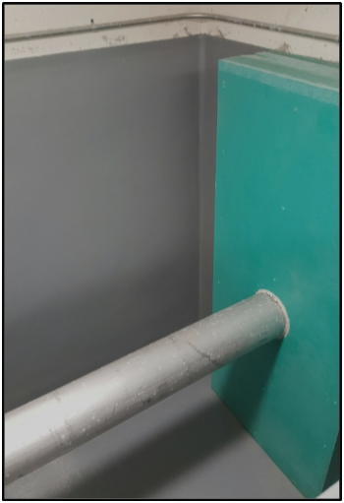

Figure 1-5: Test chamber

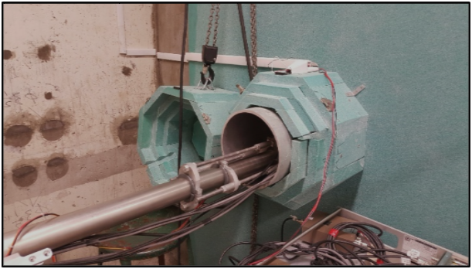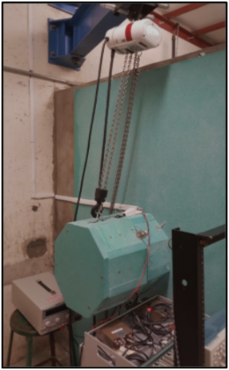

Figure 1-6: a. Open borehole tube b. Capped borehole tube

1.3 Monte Carlo Library Least Squares

In order to quantitatively analyze measured PGNAA γ spectra, monte carlo library least squares (MCLLS) has been shown to be an effective method over single peak analysis (Gardner 1997). MCLLS requires extremely accurate forward model simulations to represent the expected pulse-height spectrum obtained with a PGNAA system with a known geometry and compositional makeup. Previous studies have demonstrated the effectiveness on bulk coal (Shyu et al., 1998, 1998) and PGNAA applications (Han, 2005 and Hou, 2017). The MCLLS approach consists of:

1. Generating pulse-height spectra with MCNP or similar coding packages using assumed or known geometry and compositions.
2. Utilizing each prompt γ-ray pulse-height spectrum as a library input variable for model selection.
3. Adjusting all non-linear parameters between simulated and experimental response to treat the problem as a sum of linear responses.
4. Perform a linear library least-squares (LLS) analysis.

Assuming all non-linear physical components are correctly adjusted, the library least-squares method treats an unknown sample as the sum of the products of an elemental amount with the library spectrum of each element for each channel as given by equation 1.1.

|  |  |  |
| --- | --- | --- |
|  |  | (1.1) |

Where,

* + is the counts per channel of an unknown spectrum
  + are the library spectra, or counts in channel of element
  + is random error in counts in channel

Equation 1.1 is solved for by minimizing the reduced Chi-Square given by equation 1.2.

|  |  |  |
| --- | --- | --- |
|  |  | (1.2) |
|  |  |  |

Where,

* + is the number of degrees of freedom
  + is random error in counts in channel
  + is the variance of the random error in counts in each channel *i*

**CHAPTER 2**

**Nuclear Reactions**

Prompt gamma-ray neutron activation analysis (PGNAA) is a nondestructive, near real time technique used for bulk material identifications. PGNAA relies on neutron inelastic scatter and capture reactions to produce characteristic γ-rays used to identify minute amounts of elements in a bulk sample. Due to low cross sections for these reactions, background sources from natural radiation, activation of the NaI detector, and γ-rays from the decay of the neutron source a low signal to noise ratio (SNR) is common.

**2.1 Neutron Transport**

**2.1.1 Neutron Inelastic Scatter (n, n’γ)**

Neutron inelastic scatter involves an incoming neutron colliding with a target nucleus and exiting with less energy and at a different angle than it entered. The energy deposited on the target nucleus causes it to reach an excited state and rapidly releases a γ-ray to return to its normal energy state represented in equation 2.1 as follows:

|  |  |  |
| --- | --- | --- |
|  |  | (2.1) |

The inelastic scattering reaction requires an incoming neutron to have enough energy to break the threshold energy derived from the Q value formula shown in equation 2.2.

|  |  |  |
| --- | --- | --- |
|  |  | (2.2) |

Where,

* + is the kinetic energy of the incident neutron
  + is the energy of the target nucleus’ first excited level
  + is the atomic number of the target nucleus

The PNG is advantageous for this decay scheme, as the 14.1 MeV neutrons allow a greater number of isotopes to undergo inelastic scatter and unlock higher energy states. Table 2-1 (Kim et, al. 2006) below lists some common inelastic scatter threshold energies and cross sections.

Table 2-1: Non-elastic scattering reactions and threshold energies

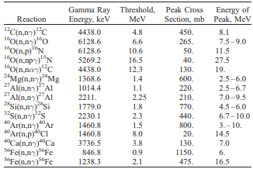

**2.1.2 Neutron Capture (n, γ)**

Neutron capture, also denoted as (n, γ), can occur over a wide range of energies and has the highest probability at thermal energies. The (n, γ) reaction begins when a neutron interacts with a target nucleus and is absorbed. The newly formed nucleus is placed in an excited state, and in order to form a new ground state, at least one γ photon is emitted as shown in eq. 2.3 below.

|  |  |  |
| --- | --- | --- |
|  |  |  |
|  |  | (2.3) |

Each nucleus (apart from Helium-4) gives off a distinct signature of intensities and energies, allowing for the identification of the sample from the γ photon emissions.

**2.2 Photon Transport**

**2.2.1 Photon Reactions**

The benchmarking tool analysis relies on three main photon reactions: photoelectric absorption, Compton scattering, and pair production. Although there are other photon reactions, none are an important focus to this work.

**Photoelectric Absorption**

During photoelectric absorption, a photon interacts with a target atom’s electron, departs all of its energy, disappears, and ejects the electron from its bound shell. The photoelectron carries an energy given by equation 2.4.

|  |  |  |
| --- | --- | --- |
|  |  | (2.3) |

Where,

* + is the binding energy of the photoelectron in its original shell
  + is the energy of the exited photoelectron
  + is the energy of the incoming photon

**Compton Scattering**

Compton scattering takes place when a photon interacts with an electron in an atom, it deflected while imparting some of its original energy, and ejects an electron from its orbit. Depending on the scatting angle, the energy transferred to the electron can range from zero to a large fraction of the total photon energy. The energy of the scattered photon and kinetic energy of the scattered electron can be calculated if the energy of the incident photon and incident angle are known by:

|  |  |  |
| --- | --- | --- |
|  |  | (2.4) |

Where,

* + is the scattered photon energy
  + is the energy of the incident photon
  + is the scattering angle in the lab frame
  + is the mass of the electron
  + is the speed of light

**Pair Production**

When an incoming photon exceeds 1.02 MeV, a photon can disappear and create an electron positron pair. All additional energy carried by the photon above 1.02 MeV is converted into kinetic energy shared by the positron and electron. Although possible at any energy above 1.02 MeV, pair production does not become the dominant reaction until photon energies exceed 5 MeV as shown in Figure 2-1.

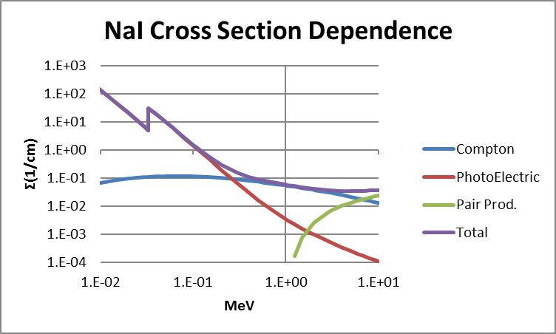

Figure 2-1: Energy dependence of photon interactions in NaI

**2.3 Detector Response**

**CHAPTER 3**

**Machine Learning Enhancements**

Many modern day advancements have been made with the assistance of machine learning techniques. Traditional methods of solving linear least squares (LLS) problems can be enhanced by utilizing ready-made packages available on MATLAB and Python coding platforms. All codes used for this investigation have been modified from the sklearn packages in Python.

**3.1 Supervised Machine Learning**

**3.1.1 Linear Least Squares**

The linear model and analysis have been thoroughly used and examined over the last half century and remains important. The linear model, given a vector of inputs , an output Y can be predicted as

|  |  |  |
| --- | --- | --- |
|  |  | (3.1) |

Where,

* + is the intercept, also known as the bias in machine learning
  + is the predicted output

can be included in the vector coefficients and a constant variable 1 in X, allowing equation 3.1 to be rewritten as

|  |  |  |
| --- | --- | --- |
|  |  | (3.2) |

Where,

* + is the vector or matrix transpose
  + is the predicted output
  + is the linear coefficient

Fitting a linear model to a training data set is popularly done by selecting the coefficients that minimize the residual sum of squares

|  |  |  |
| --- | --- | --- |
|  |  | (3.3) |

**3.1.2 Least Absolute Selection and Shrinkage Operator (LASSO)**

The least absolute selection and shrinkage operator (LASSO) method became popular as a statistical and modeling method to reduce or eliminate unnecessary variables from a model (Tibshirani 1996). The LASSO method utilizes tuning parameters to shrink and select variables placed in a linear model by reducing predictive error between in and out of sample tests, also known as test/train splitting in machine learning. LASSO is defined as

|  |  |  |
| --- | --- | --- |
|  | Or | (3.4) |

Where,

* + is the loss function
  + is a tuning parameter that serves as a penalty
    - Note: when , eq. 3.4 is identical to linear least squares (LLS)